LEARN TO RIDE

High-quality **Western and English** riding lessons, focusing on safety and including instructions on house care, saddling a horse and other aspects of horsemanship

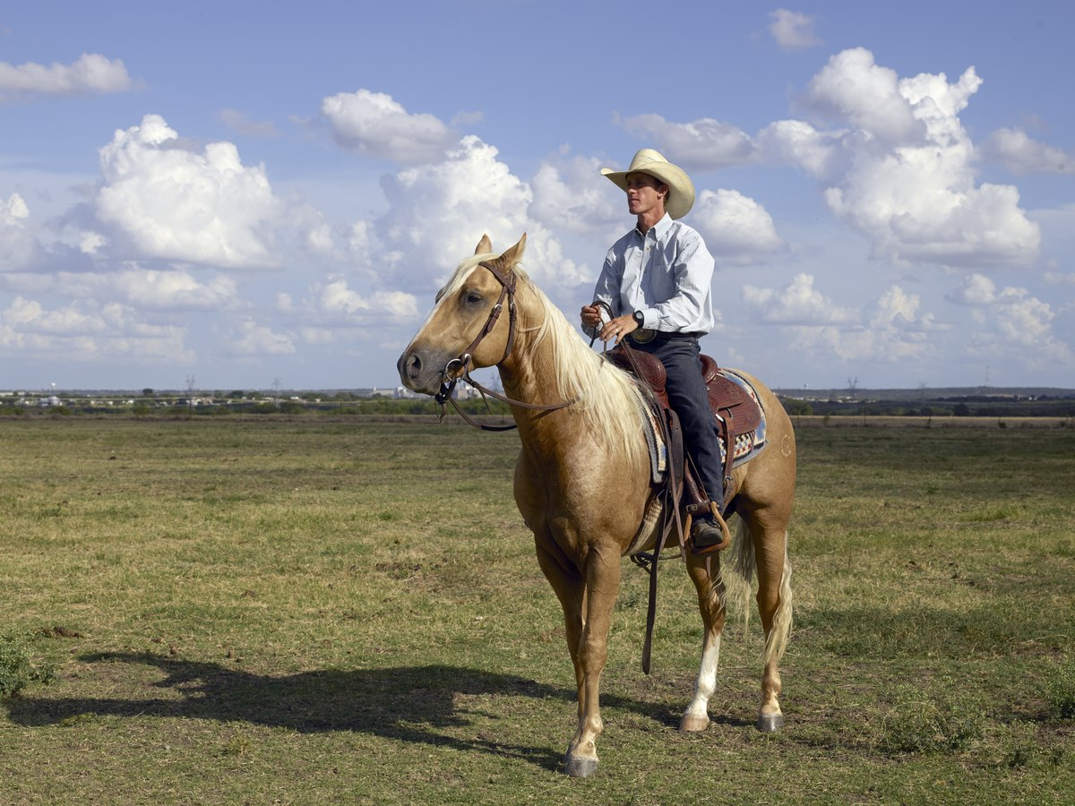

[This Photo](https://en.m.wikipedia.org/wiki/Horse_trainer) by Unknown Author is licensed under [CC BY-SA](https://creativecommons.org/licenses/by-sa/3.0/)

* Novice to advanced instructions for children and adults
* Indoor and outdoor arenas
* $40 per hour for private lessons, $25 for group lessons

CALL TRI-VALLEY STABLES AT 555-2030 TODAY!

|  |  |  |  |  |  |  |
| --- | --- | --- | --- | --- | --- | --- |
| Oratile’s Sweet Cake Bakery  Every Flavour has a Story! | | | | | | |
| Bill to:  Name ___________________________________  Address ___________________________________ City/Prov/State ___________________________________  Postal/Zip Code ___________________________________ | | | | Ship to:  Name  _______________________________  Address  _______________________________  City/Prov/State  ______________________________  Postal/Zip Code  ______________________________ | | |
|  | | | | | | |
| **QUANTITY** | **ITEM** | | **STYLE** | **TYPE** | **UNIT COST** | **COST** |
|  |  | |  |  |  |  |
|  |  | |  |  |  |  |
|  |  | |  |  |  |  |
|  |  | |  |  |  |  |
|  |  | |  |  |  |  |
|  |  | |  |  |  |  |
|  |  | |  |  |  |  |
|  |  | |  |  |  |  |
|  |  | |  |  |  |  |
| Shipping: | |
| Tax | |
| Total Order: | |